**Front-End UI/UX Mini Project**

**1. Title Page**

* **Project Title**: Personal Diary UI Notebook theme
* **Submitted By**: 
  + *Team Members-*

Adi Sankar KB (2460308)

Blesson Baby (2460346)

Chris Paul (2460350)

* + *College-E-mailid-*

*adi.sankar@btech.christuniversity.in*

*blesson.baby@btech.christuniversity.in*

*chris.paul@btech.christuniversity.in*

* **Course**: *UI/UX Design Fundamentals*
* **Instructor Name**: *Dhiraj Alate.*
* **Institution**: *Christ University*
* **Date of Submission**: *12/08/2025*

**2. Abstract**

The Interactive Personal Diary is a web-based application designed to provide users with a visually appealing and user-friendly platform for recording daily thoughts, experiences, and reflections. Built using HTML and CSS, the diary offers a clean, paper-like aesthetic with a calming color palette and typography inspired by handwritten notes.

The application utilizes contenteditable fields, allowing users to freely input and edit dates, titles, and diary entries directly within each card-style note. A “sticky note” style date tab and elegant labels help organize entries, while a Save Entry button facilitates the storage process (functionality to be integrated with JavaScript or backend services in future versions). The layout is optimized for both desktop and mobile viewing through responsive design techniques.

This project is intended as both a creative writing tool and a digital journaling experience, combining the personal feel of a traditional diary with the convenience of a digital interface. Its modular structure allows for easy extension — such as adding local storage, cloud sync, search functions, or multimedia content support — making it a scalable platform for more advanced personal record-keeping solutions.

**3. Objectives**

* Create an easy-to-use, visually appealing online diary for daily thoughts, events, and reflections.
* Preserve a traditional diary feel using a warm palette, elegant typography, and paper-like design.
* Enable direct typing and editing for dates, titles, and entries via editable fields.
* Ensure a responsive layout that works smoothly on both desktop and mobile devices.
* Keep the structure expandable for future features like local storage, cloud sync, search, and multimedia attachments.
* Encourage regular journaling habits and long-term personal record keeping.

**4. Scope of the Project**

* Provides a web-based platform for personal journaling accessible from any device with a browser.
* Allows users to create, edit, and organize diary entries with editable date, title, and content fields.
* Offers a visually appealing and comforting interface inspired by traditional diaries.
* Supports responsive design for optimal viewing on desktop, tablet, and mobile screens.
* Can be enhanced with features like local storage, cloud backup, multimedia attachments, search, and categorization in future versions.
* Suitable for personal use, creative writing, daily reflection, or as a base for educational or therapy-related journaling tools.
* Can be customized for branding or personalized themes for different target audiences.

**5. Tools & Technologies Used**

| Tool/Technology | Purpose |
| --- | --- |
| HTML5 | Markup and content structure |
| CSS3 | Styling and layout management |
| VS Code | Code editor |
| Chrome DevTools | Testing and debugging |

**6. HTML Structure Overview**

* Used semantic tags: <header>, <nav>, <main>, <section>, <footer>
* Structured into reusable sections: About, Projects, Contact
* Navigation menu using <ul> and anchor links for smooth scrolling

**7. CSS Styling Strategy**

* Use CSS variables for colors, fonts, and spacing to make theming easy.
* Follow a structured approach with sections for base styles, layout, components, and responsive rules.
* Apply semantic class naming (like BEM) for clarity and reuse.
* Maintain a consistent color palette and typography for a diary-like feel.
* Design a responsive layout that works on all screen sizes.
* Use hover, focus, and active states for better interactivity.
* Keep editable fields visually distinct with clear focus styles.
* Style navigation for clarity and highlight active/hover states.
* Add spacing and shadows for depth without overcomplicating visuals.
* Ensure accessibility with proper contrast and visible focus indicators.

**8. Key Features**

| Feature | Description |
| --- | --- |
| Responsive Design | Adapts seamlessly to all screen sizes |
| Smooth Navigation | Fixed top nav with anchor links |
| Project Cards | Flex-based layout with hover effects |
| Contact Form (non-functional) | Placeholder layout for inputs and button |
| Accessible Fonts & Colors | High contrast and readable typography |

**9. Challenges Faced & Solutions**

| Challenge | Solution |
| --- | --- |
| Overlapping elements on small screens | Used media queries to stack elements |
| Difficulty aligning items using float | Shifted to Flexbox and Grid |
| Typography scaling issue | Used relative units (em/rem) instead of px |

**10. Outcome**

* Achieved a clean, consistent, and visually engaging front-end layout
* All key components function as intended using just HTML and CSS
* Learned about layout responsiveness and UI hierarchy in depth

**11. Future Enhancements**

* Add secure save, cloud sync, and privacy features like passcode or encryption.
* Include reminders, mood tracking, and quick capture (voice, photo, location).
* Enable tags, search filters, and export to PDF or other formats.
* Offer themes, dark mode, and customizable layout options.

**12. Sample Code**

**Namma News English version**

<!DOCTYPE html>

<html lang="en">

<head>

<meta charset="UTF-8" />

<meta name="viewport" content="width=device-width, initial-scale=1" />

<title>Interactive Personal Diary (Blank - User Ready)</title>

<!-- Google Fonts -->

<link href="https://fonts.googleapis.com/css2?family=Dancing+Script&family=Merriweather&display=swap" rel="stylesheet" />

<style>

:root {

--cream: #fef9f3;

--paper-yellow: #fff8dc;

--soft-brown: #a47e52;

--pastel-brown: #d4b483;

--shadow-color: rgba(101, 67, 33, 0.18);

--text-color: #563d1f;

--line-color: #e4d9c6;

--border-color: #cbbf9f;

--sticky-gradient: linear-gradient(160deg, #fff7d6 0%, #fbe7b5 100%);

--background-gradient: linear-gradient(90deg, #fef9f3 0%, #fff8dc 100%);

--button-color: #d4b483;

--button-hover: #a47e52;

}

body {

margin: 0;

font-family: 'Merriweather', serif;

background: var(--background-gradient);

color: var(--text-color);

line-height: 1.6;

min-height: 100vh;

background-image:

repeating-linear-gradient(

to bottom,

transparent,

transparent 28px,

var(--line-color) 29px,

var(--line-color) 30px

);

background-attachment: fixed;

}

header, footer, main {

max-width: 900px;

margin: 1rem auto;

padding: 1.5rem 2rem;

border-radius: 14px;

box-shadow: 0 6px 15px var(--shadow-color);

background: var(--cream);

border: 1px solid var(--border-color);

}

header {

text-align: center;

}

.diary-title {

font-family: 'Dancing Script', cursive;

font-size: 3rem;

color: var(--soft-brown);

margin: 0;

letter-spacing: 1.5px;

text-shadow: 1px 1px 1px #f7ecd3;

}

.quote {

font-style: italic;

color: var(--pastel-brown);

margin-top: 0.5rem;

font-size: 1.3rem;

}

/* Entries Layout */

.entries {

display: flex;

flex-direction: column;

gap: 2rem;

margin-bottom: 2rem;

}

.entry-card {

background: var(--paper-yellow);

border: 1.25px solid var(--border-color);

border-radius: 16px;

padding: 2rem;

position: relative;

box-shadow: 0 8px 20px var(--shadow-color);

font-family: 'Merriweather', serif;

color: var(--text-color);

}

.entry-card:hover {

box-shadow: 0 12px 30px rgba(101,67,33,0.22);

}

/* Date Tab */

.date-tab {

position: absolute;

top: 1rem;

left: -1.8rem;

background: var(--sticky-gradient);

color: #7a5e28;

font-weight: 700;

font-family: 'Dancing Script', cursive;

padding: 0.5rem 1.1rem;

border-radius: 8px;

font-size: 1.3rem;

transform: rotate(-3deg);

border: 1px solid #e0d28c;

box-shadow: 2px 3px 6px rgba(0,0,0,0.15);

user-select: none;

}

/* Labels */

.label {

font-weight: bold;

color: var(--soft-brown);

font-family: 'Dancing Script', cursive;

font-size: 1.3rem;

margin-bottom: 0.3rem;

display: block;

}

/* Editable fields styling */

[contenteditable] {

border: 1.5px dashed var(--pastel-brown);

border-radius: 8px;

padding: 8px 12px;

min-height: 1.5em;

box-shadow: inset 1px 1px 6px rgba(255, 255, 255, 0.7);

transition: background-color 0.3s ease;

}

[contenteditable]:empty:before {

content: attr(data-placeholder);

color: #a19884;

font-style: italic;

}

[contenteditable]:focus {

background-color: #fffde7;

box-shadow: 0 0 8px var(--soft-brown);

}

/* Title Inside Card */

.entry-title {

font-family: 'Dancing Script', cursive;

color: var(--soft-brown);

font-size: 2rem;

margin-top: 0.3rem;

margin-bottom: 1rem;

}

/* Beautiful Button */

.save-button {

display: inline-block;

background-color: var(--button-color);

color: #fff;

font-family: 'Dancing Script', cursive;

font-size: 1.4rem;

font-weight: bold;

padding: 0.5rem 1.5rem;

border: none;

border-radius: 30px;

cursor: pointer;

margin-top: 1rem;

transition: background-color 0.3s ease, transform 0.2s;

}

.save-button:hover {

background-color: var(--button-hover);

transform: scale(1.05);

}

.save-button:active {

transform: scale(0.98);

}

footer {

text-align: center;

font-size: 1rem;

color: var(--pastel-brown);

}

@media (max-width: 768px) {

.date-tab {

font-size: 1.05rem;

left: -1.4rem;

padding: 0.4rem 0.8rem;

}

.entry-title {

font-size: 1.6rem;

}

}

</style>

</head>

<body>

<header>

<h1 class="diary-title">My Personal Diary</h1>

<p class="quote">"Each day is a new page of your story."</p>

</header>

<main>

<section class="entries">

<!-- Blank Entry Template -->

<article class="entry-card">

<div class="date-tab" contenteditable="true" data-placeholder="Date Tab (e.g., Aug 15⁵)"></div>

<span class="label">Date:</span>

<p contenteditable="true" data-placeholder="Type full date here..."></p>

<span class="label">Title:</span>

<h2 class="entry-title" contenteditable="true" data-placeholder="Type your title here..."></h2>

<span class="label">Entry:</span>

<p contenteditable="true" data-placeholder="Write your diary entry here..."></p>

<p contenteditable="true" data-placeholder="Continue writing..."></p>

<!-- Save Entry Button -->

<button class="save-button">💾 Save Entry</button>

</article>

</section>

</main>

<footer>

<p>© 2025 My Personal Diary</p>

</footer>

</body>

</html>

**13. Screenshots of Final Output**

**English version (in desktop)**

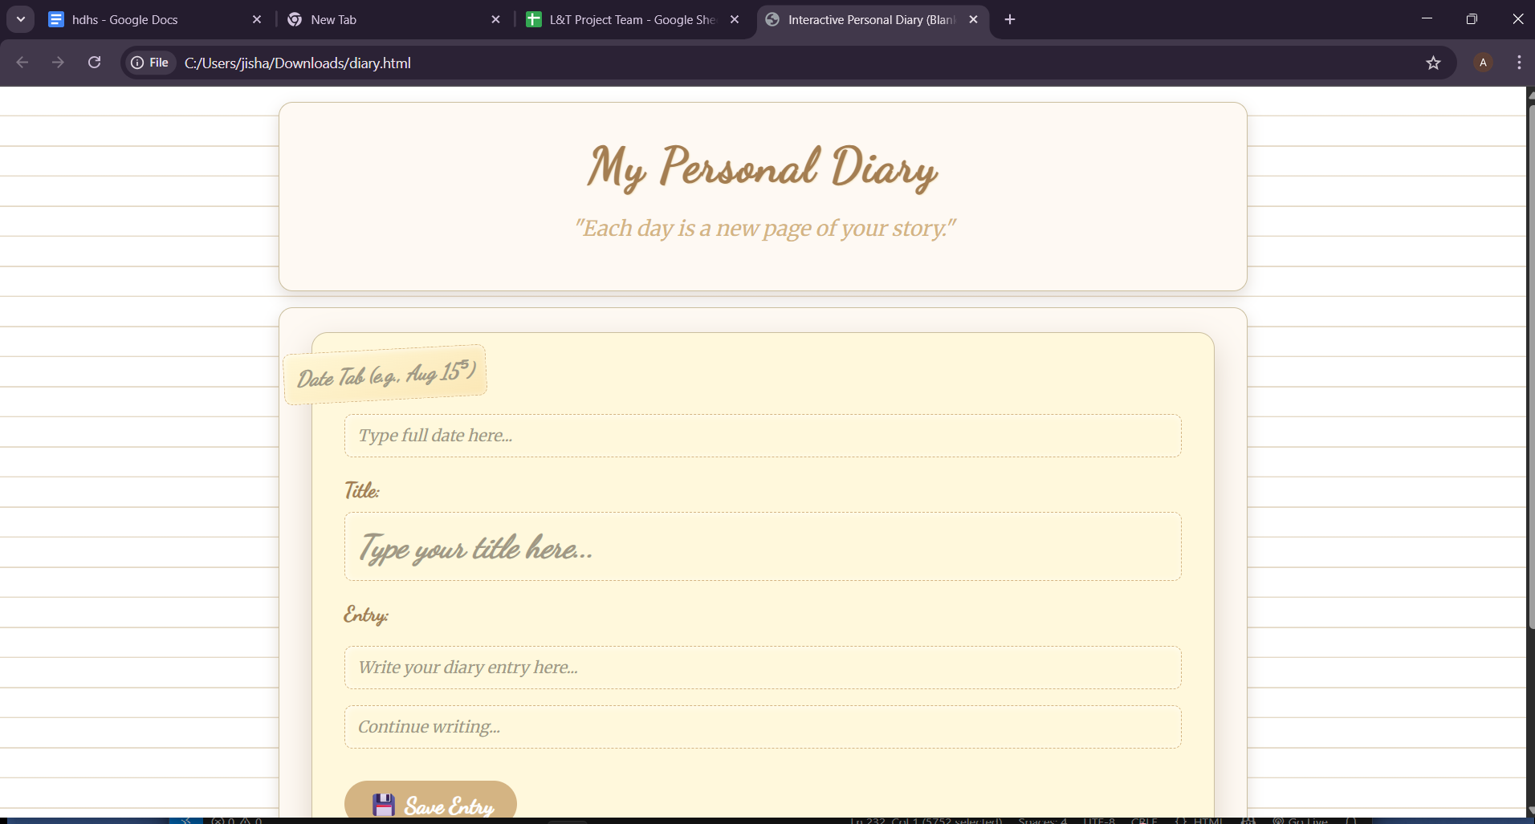

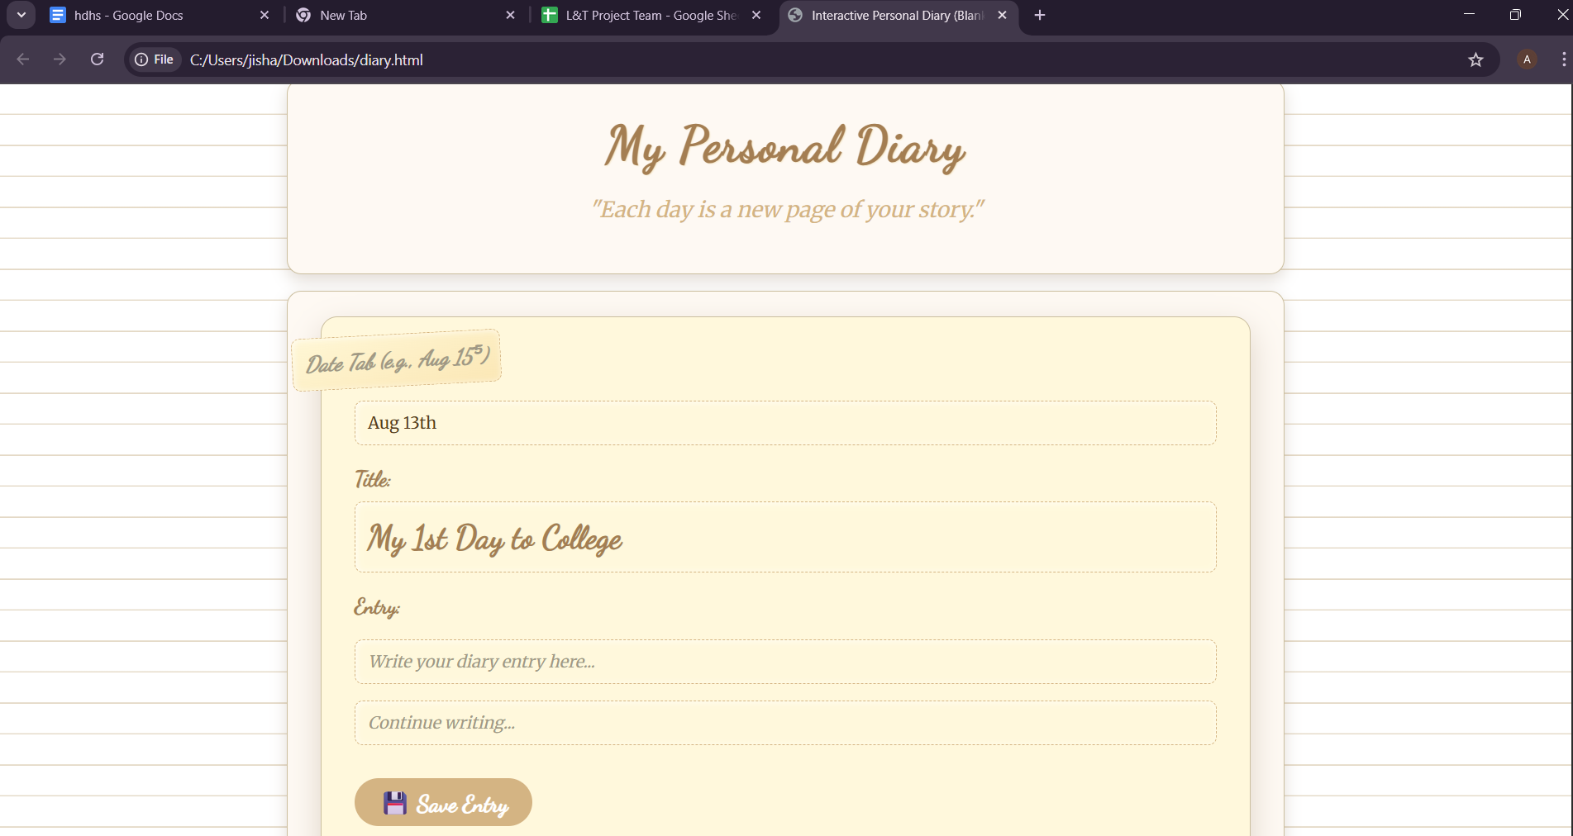

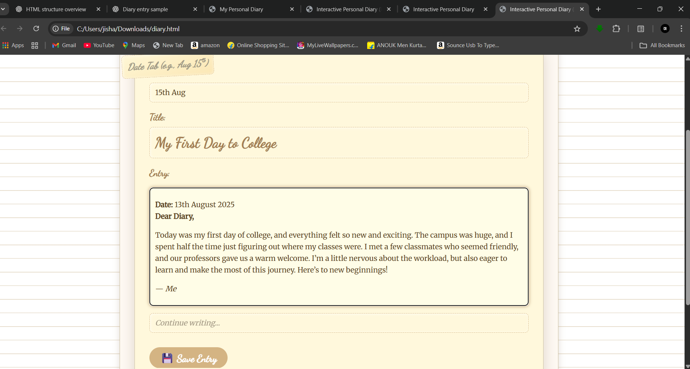

**11. Conclusion**

This is an Interactive Personal Diary web project that allows users to create, edit, and organize diary entries with a clean, diary‑like aesthetic. It features editable fields for dates, titles, and content, along with a responsive design for seamless use on any device.

This mini project helped me strengthen my HTML and CSS skills, particularly in semantic structuring, layout design, and responsive styling. I gained practical experience in creating an engaging user interface, using CSS variables for theming, and applying design principles to enhance the overall user experience.

**12. References**

* L&T LMS : https://learn.lntedutech.com/Landing/MyCourse